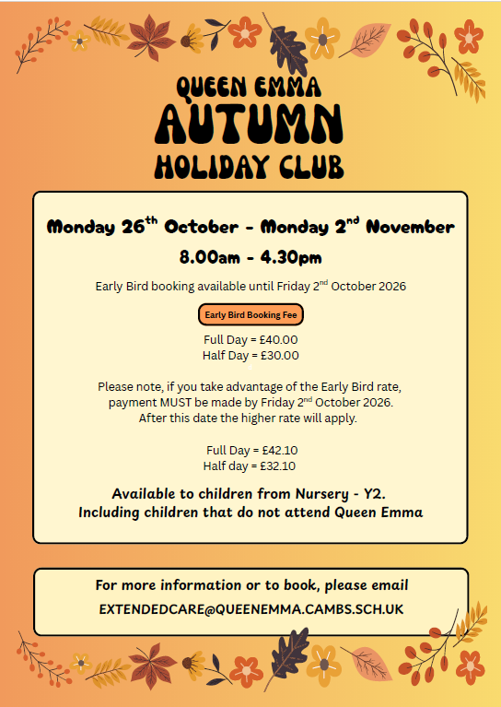
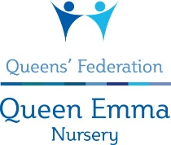
Holiday Club Enquiry

- We offer sessions between 8:00 am – 4:30 pm.
- If your child is staying for either the morning or afternoon session only they will require one healthy snack from home. If they are staying all day they will need to be provided with two snacks from home.
- Lunchtime will be between 12:30 – 1:00 pm, so please bring a packed lunch for your child if staying all day.
- PLEASE NOTE WE ARE A NUT FREE SCHOOL.
- We will provide the children with drinks during the sessions.
- Please be prompt to pick up your child at the end of the sessions. If you are late, you will be charged an additional fee of £5.00 per 5 minutes to cover staff costs.
- Fees are payable during periods of absence from the Holiday Club, including sickness.

Book now to avoid disappointment.
Places will be allocated on a first come, first serve basis.

Please tick the boxes to show which sessions you wish to book and hand it in at the School or Nursery Office. Thank you.

Child’s Name: ......................................................................................

Child’s School ……………………………. Class …………………………………………

 | AM Session  (8:00am - 12:30pm) | PM Session  (12.30 - 4:30pm) | All Day  (8:00am-4:30 pm)
Monday 26th October
Tuesday 27th October
Wednesday 28th October
Thursday 29th October
Friday 30th October
Monday 2nd November

- Please speak to Melissa Reynolds or Laura Dunn prior to booking if your child has special needs.
- On receipt of your booking form we will confirm your sessions and issue an invoice, which must be paid for before Friday 2nd October 2026 to ensure the early bird booking rates.
- Invoices can be paid BACs, childcare vouchers, Tax Free Childcare or via School Comms if you are a Queen Emma parent.

Email address ......................................................................................
(for booking confirmation)

Contact Melissa Reynolds, Nursery Administrator at extendedcare@queenemma.cambs.sch.uk or 01223 714305 for further information.

QUEEN EMMA HOLIDAY CLUB
PUPIL ADMISSION FORM

PUPIL DETAILS:
Forename: | Surname:
Gender: Male/Female | Date of birth:
Child’s place of birth: | Child’s religion:
Please List any dietry or medical conditions:

PARENTS’ DETAILS:
Mother: Title: Forename:  Surname: | Father: Title: Forename:  Surname:
Relationship to pupil (e.g. natural mother, stepmother, foster mother, guardian): | Relationship to pupil (e.g. natural father, stepfather, foster father, guardian):
Address: | Address (if different from opposite)
Home Tel No: | Home Tel No:
Mobile Tel No: | Mobile Tel No:
Work Tel No: | Work Tel No:
Email: | Email:
Mother’s place of birth: | Father’s place of birth:
Who has Parental Responsibility for the child?

(Mothers and fathers married at the time of birth automatically have parental responsibility unless legal proceedings have stated otherwise. Unmarried fathers only have parental responsibility if they are named on the birth certificate and the child was born after 1st December 2003. For further information, please ask in the office, where you can be given a leaflet about parental responsibility).

- If you provide an email address we will assume you are giving us consent to add you to our parent email list.

We ask all parents to provide a pick up password. You may need someone different to pick up your child and we will ask them for the pick up password in order to ensure your child’s safety.
Pick up password:

